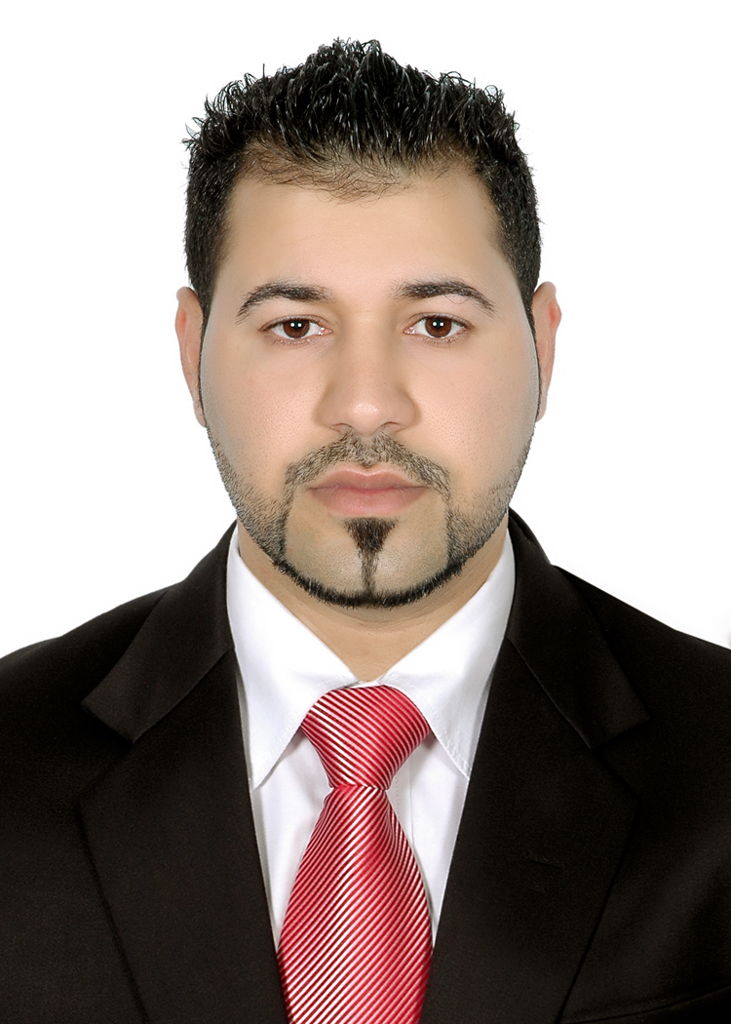
Curriculum Vita

Personal Details:

Name: | Habib abdul shaheed habib
Date of birth: | 3 February 1989
Nationality: | Bahraini
Marital status: | Married
Address: | Flat: 12, House: g1428, Road: 5228,  Boury: 752
Telephone number: | : (+973) 66333784

Work experience:

Company | Job Description
UNITAG | Assistant factor
Zone security.co | Security guard
Secure me security.co | Security guard

Education and qualification:

Data | School | Certificate
29-6-2009 | Tawon Secondary School for Boys | Secondary certification.
19-7-2009 | Tylos human development | The development of job performance.
31-5-2015 | Guards training school | Basic security operative course

Additional skills:

Skills: | - Professional Computer Skills:  - MS-Office: Word, Excel and PowerPoint. Email management.  - Communication and Interpersonal Skills:  - Adaptability to Change, Oral Presentations (good English & Arabic), Team Work, Self-confidential and Self-starter.  - Work Pressure Management Ability to work under pressures and different working hours.
Driving: | - Bahraini License
Computer: | - Microsoft Windows  - Excel, Power point, Publisher, word  - Familiar with Internet
Languages: | - Arabic – written & spoken  - English – written & spoken
Hobbies: | - Reading, writing, traveling, works as team member

